**DATA STRUCTURE(LAB)**

**NAME:safdar ali**

**REG NO: 084**

1. **Write a program to take numbers from user and stored into stack. Pop the values from stack and show only even values on screen and show highest marks on the screen.**

**CODE:**

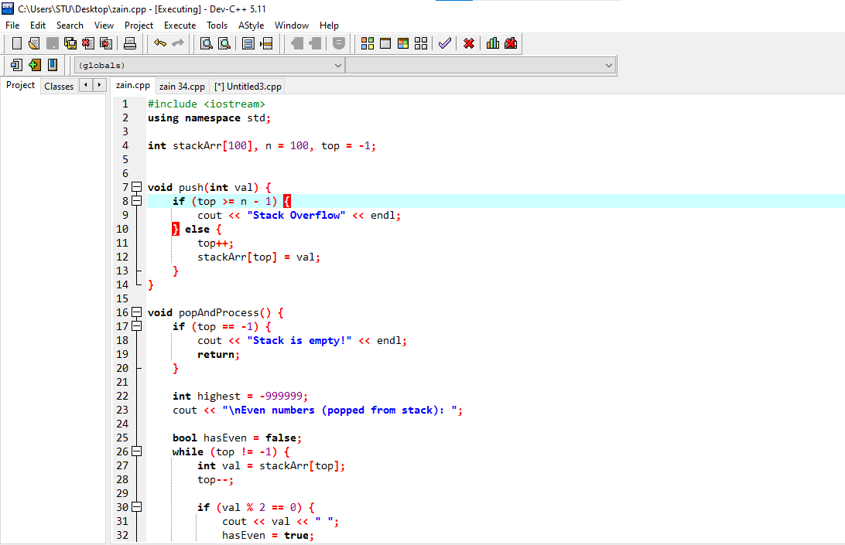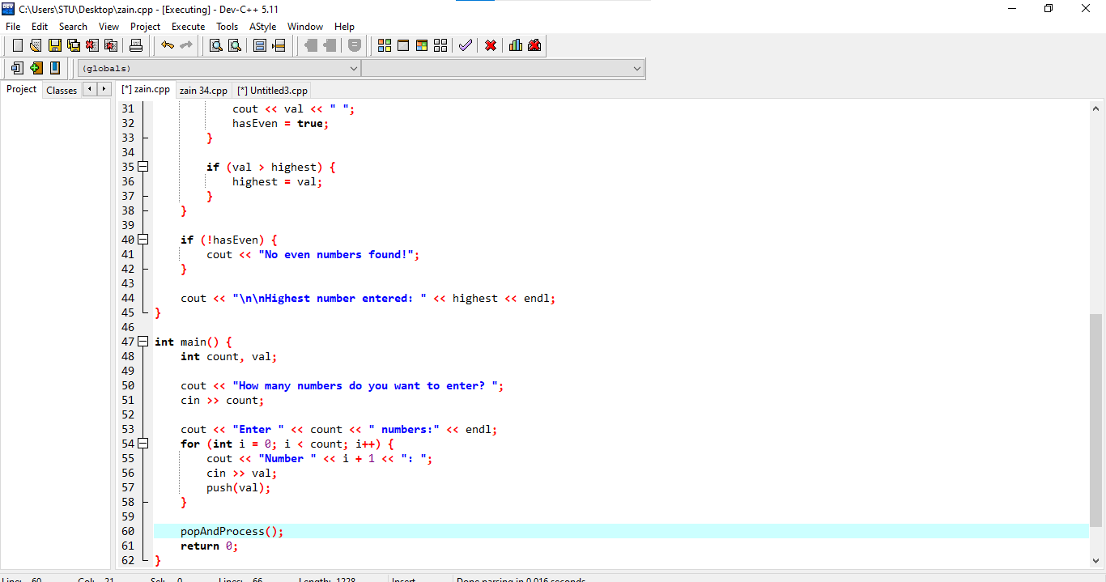

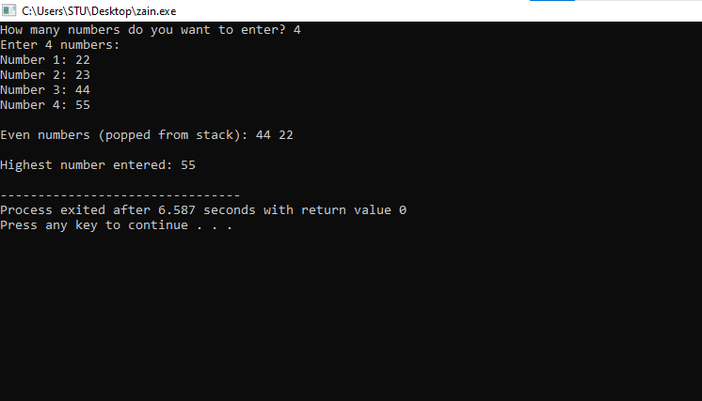

1. **Write a program to input an infix expression into a string variable. Convert the expressioninto post-fix notation by using a stack.**

**CODE:**

